VISUALIZATION OF DECISION TREE

Aim: Ta visualize the decision tree using iris dataset in python

Program:

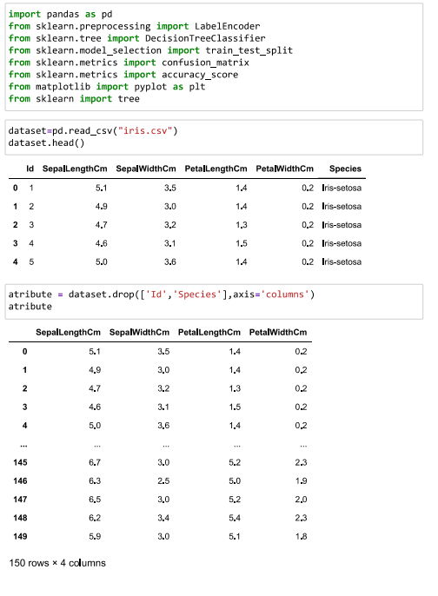

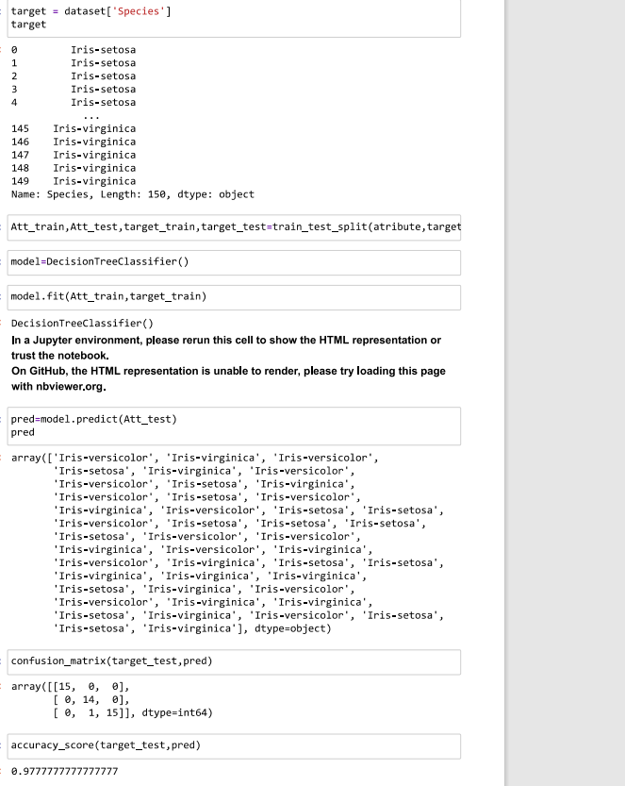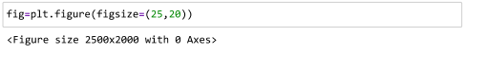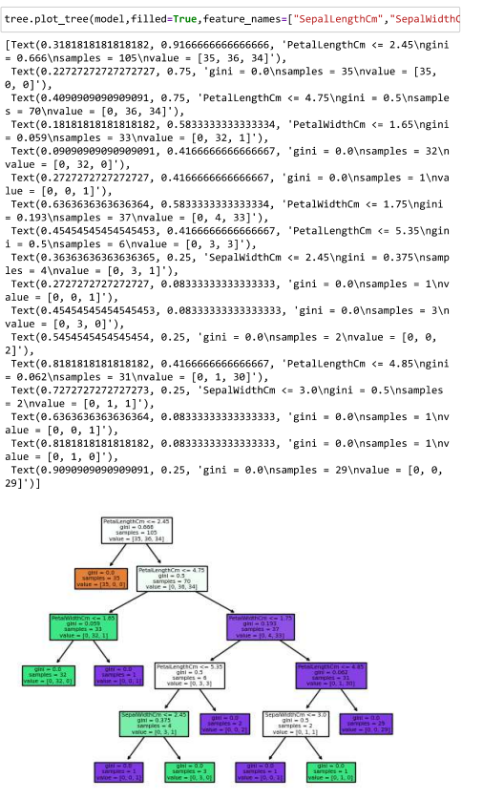

BAYESIAN

Aim: Classification of Data using Bayesian Approach

Program:

